28.

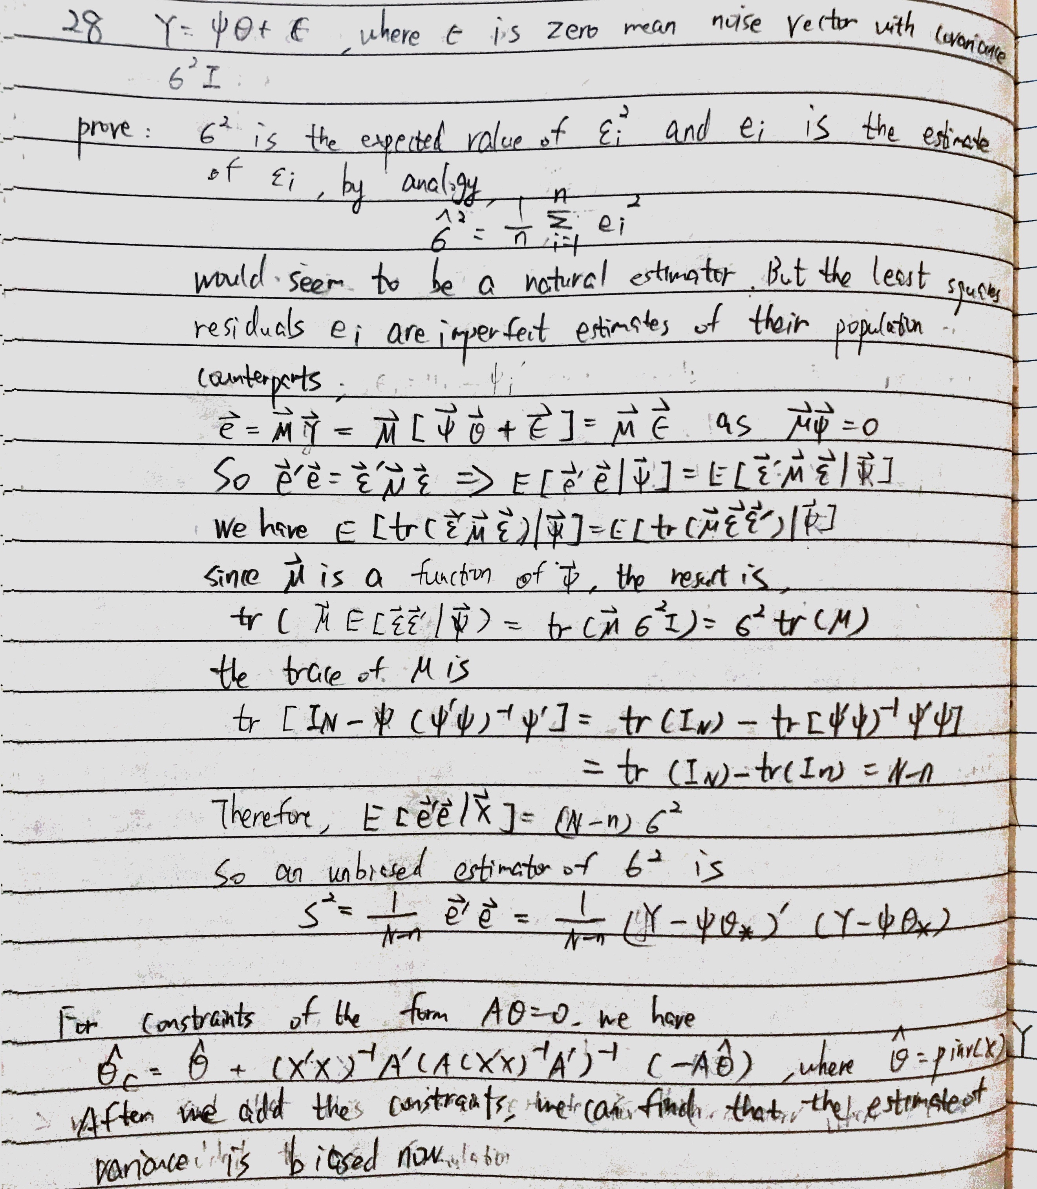

matlab result: before we add constraints: sigma=0.9995

after we add constraints: sigma= 1.6826

conclusion: biased after adding constraints

30.

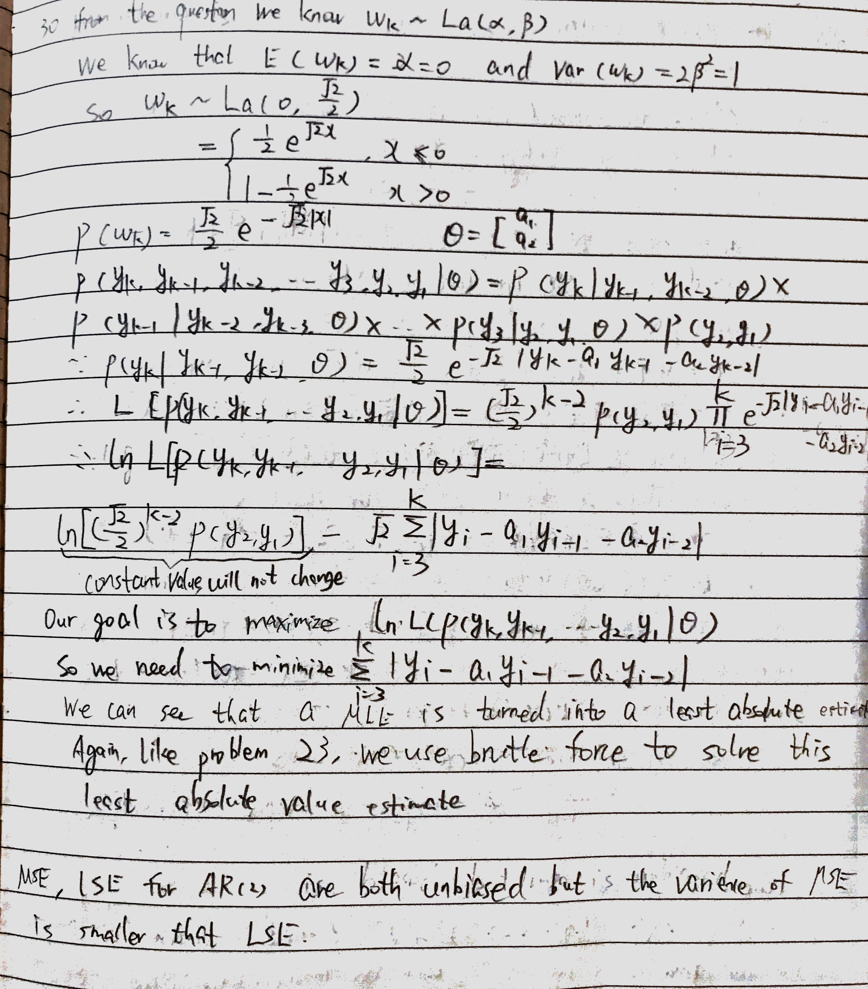

31.

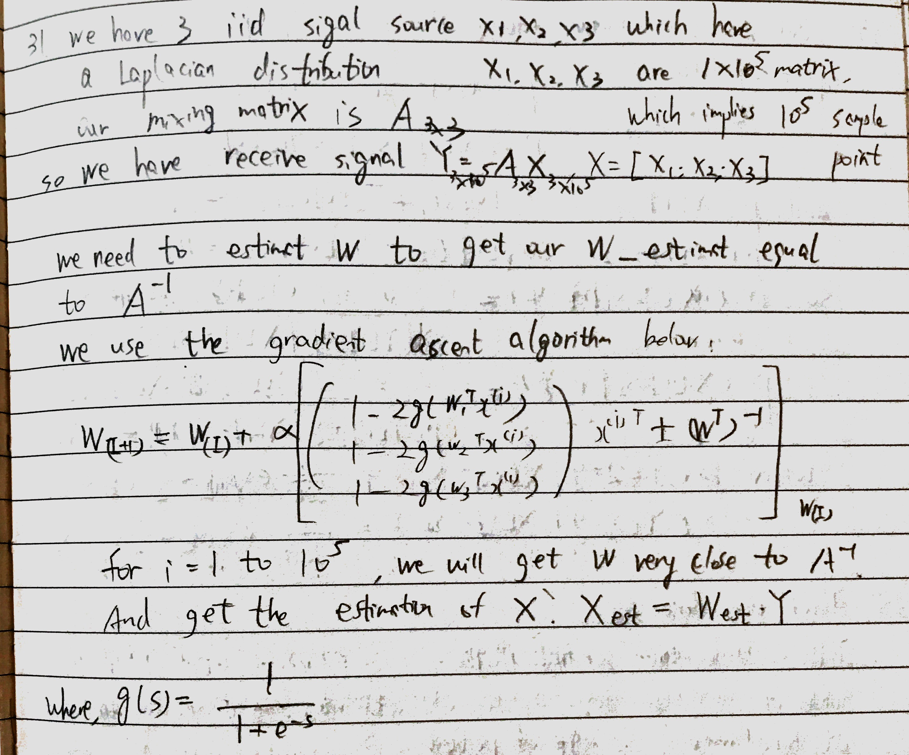

Some test results:

1.The true W matrix is W_Standard= [-1.09 2.24;1.52 -0.28]

what we get by ICA is W=[ -0.107 2.18;1.36 -0.35]

It's pretty close to the true reverse matrix W.

2.sometimes due to the reverse phase of signal, the estimation will be wrong.

34.

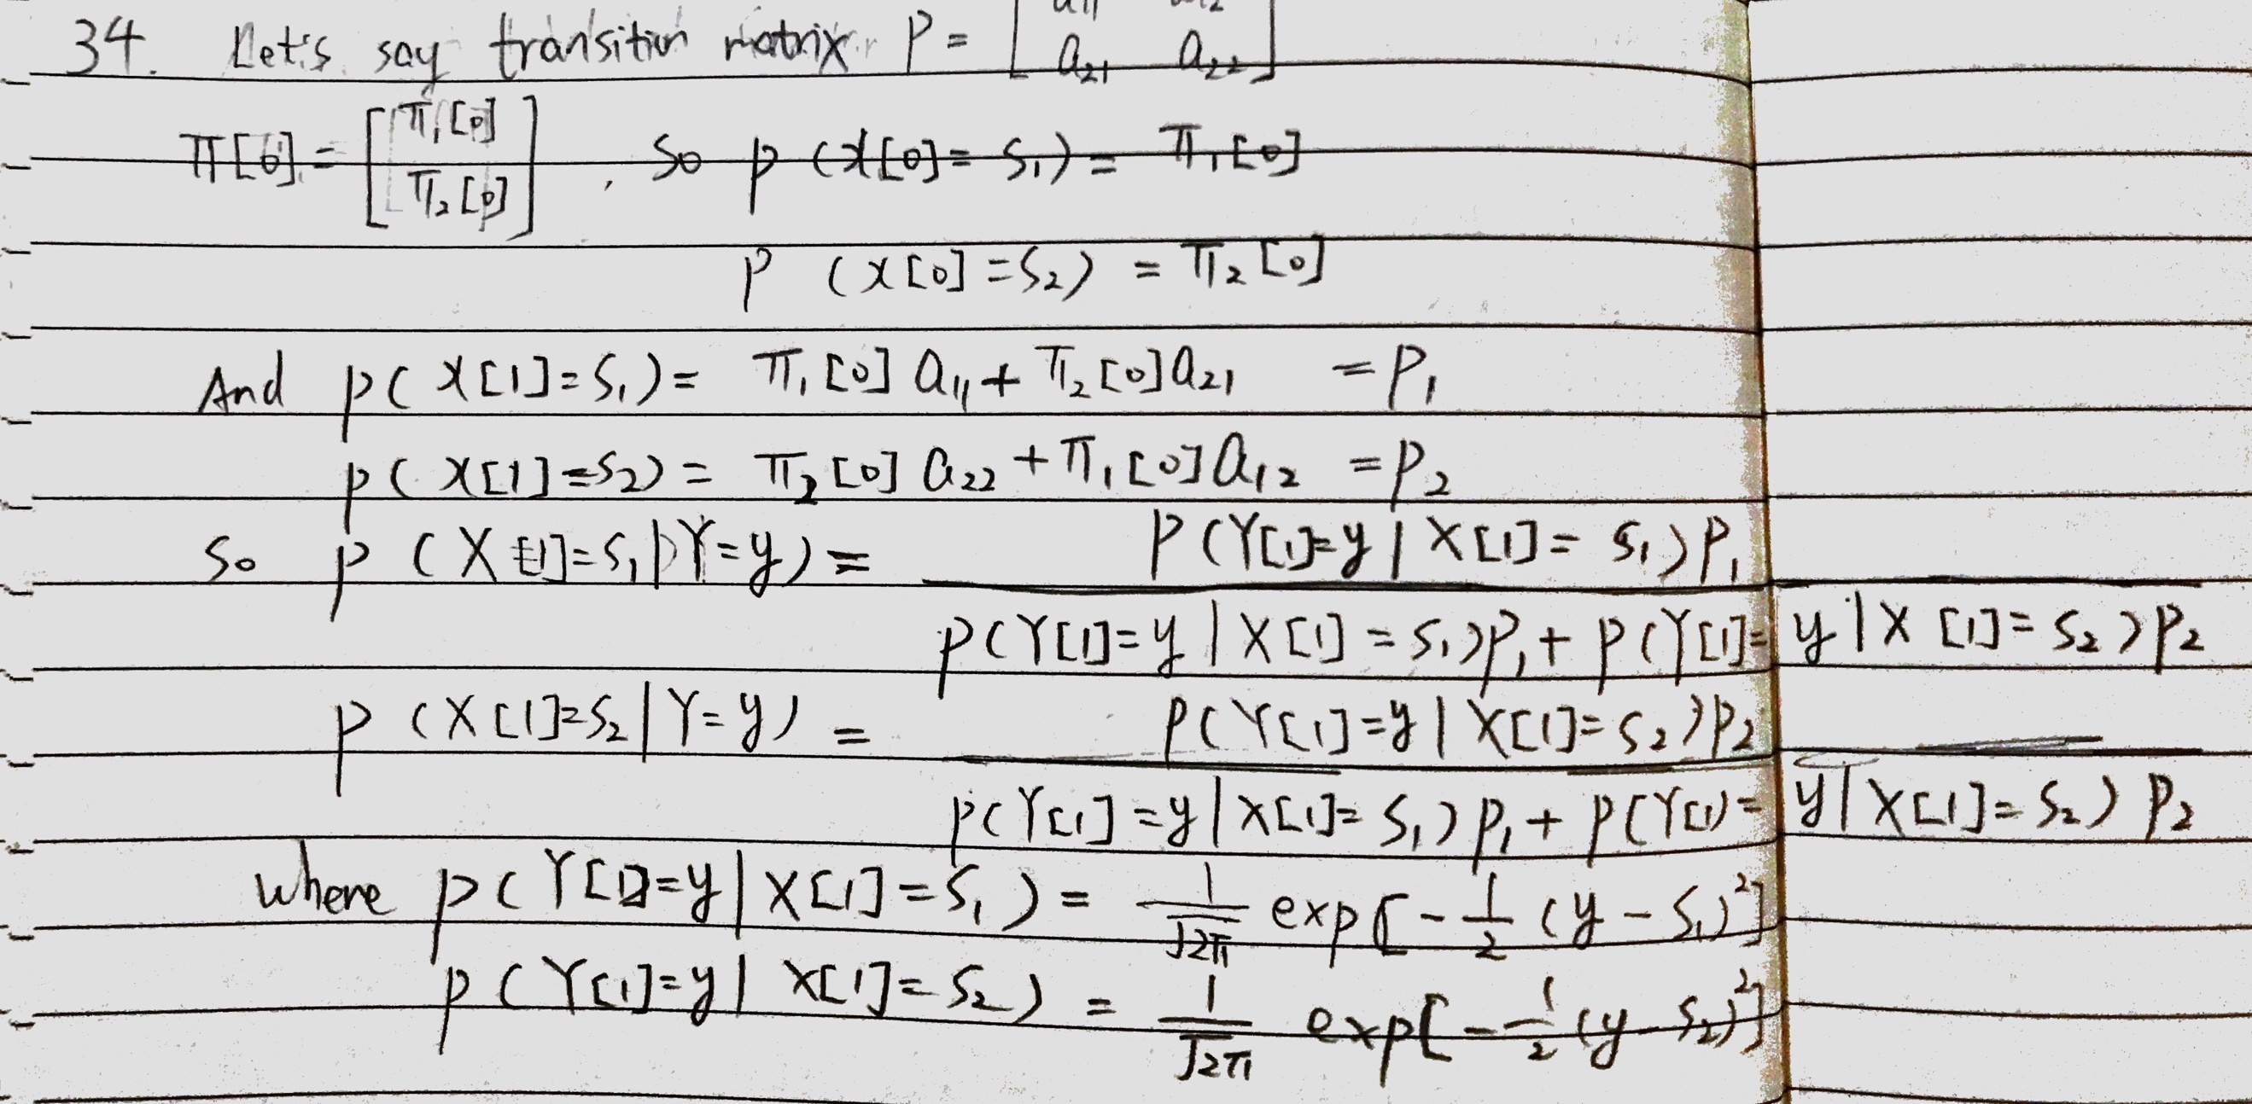

35.

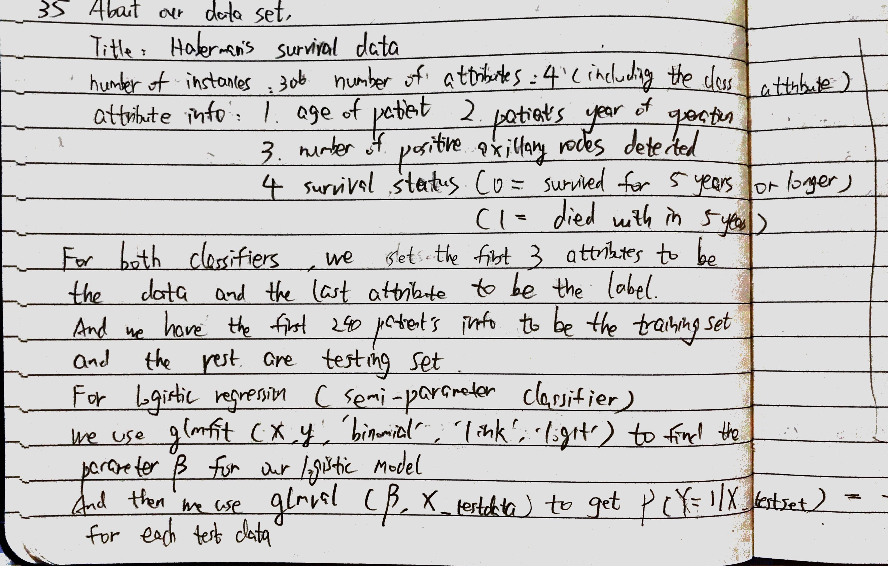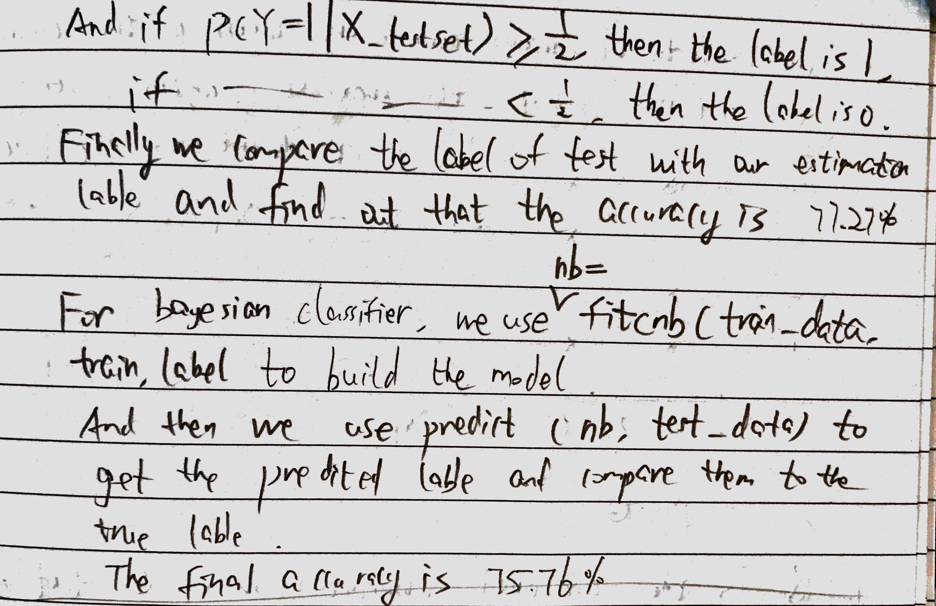

36/37.

